**TITLE: MODIFICATION AND FABRICATION OF INBUILT AUTOMATIC CONTROLLED HYDRAULIC JACK**

**PRESENTED BY: JOEL MITHAMO GACHAU**

**INDEX NUMBER:**

**COLLEGE NUMBER: 22631**

**INSTITUTION NAME: THE NYERI NATIONAL POLYTECHNIC**

**SUBJECT CODE: 2503**

**SUPERVISOR NAME: MR. KARIMI**

**SUBMITTED TO: KENYA NATIONAL EXAMINATION COUNCIL FOR**

**PARTIAL FULFILMENT FOR THE AWARD OF A DIPLOMA IN AUTOMATIVE ENGINEERING**

**COURSE: DIPLOMA IN AUTOMOTIVE ENGINEERING**

**SERIES:**

# Declaration

I declare that this is my original document and no person has ever presented the same to the Kenya National examination council or any other body for the award of diploma in Automotive Engineering

Name:

Signature:………………………………

Date:…………………………………..

**SUPERVISOR**

This project has been submitted for examination with my approval as the course supervisor.

**Mr. Karimi**

Sign………………………..………

Date………………………..…….

# Dedication

Special dedication goes to my parents for their financial and moral support which they gave me in college, your support will always be treasured in my heart. Other special dedication goes to my teachers for their support.

# Acknowledgement

My sincere gratitude goes to my lecturers for their professional and academic guidance and encouragement, my mother for her materials and financial support.

# Table of contents

Declaration ii

Dedication iii

Acknowledgement iv

Table of contents v

Abstract viii

CHAPTER ONE 1

1.0 Introduction 1

1.1 Problem statement 2

1.2 Objectives 2

1.3 Advantages 2

1.4 Disadvantages 3

1.5 Limits 3

1.6 Application of the project 4

1.7 Hypothesis 4

CHAPTER TWO 6

2.0 Introduction 6

2.1 Block diagram of the proposed remote control inbuilt hydraulic jack. 8

2.1.1 Remote control transmitter 8

2.1.2 Receiver and driver interface 8

2.1.3 Jack control motor mechanism 9

2.2 Design analysis and the remote control 9

2.2.0 Design specification 9

2.2.1 Power supply 9

2.2.2 Design of the Infra-Red Transmitter 10

2.2.3 Infra-red receiver 10

2.2.4 Micro-controller circuit 12

2.3 The cage material selection 12

2.3.1The pumping unit 13

2.3.2 The reservoir 13

2.3.3 House connections and fittings 13

2.3.4 Check values 13

2.4.5 The pumping and working cylinders 13

3.0 Working principle of the inbuilt hydraulic jack 14

3.1 Design calculation for hydraulic jack 15

3.2.1 Steps to use and operate 16

3.3 Return spring 17

3.4 Cam 17

3.5 Motor 17

CHAPTER FOUR 18

4.1 Properties 18

4.1.1 Physical properties 18

4.1.2 Mechanical properties 18

4.1.3 Manufacturing point of view 19

4.2 manufacturing case 19

4.3 Quality required 19

4.4 Availability of material 20

4.5 Space consideration 20

4.6 Cost 20

CHAPTER FIVE 21

5.0 Results and conclusion 21

5.1 Parameter measured 21

5.2 Conclusion 21

5.3 Recommendation 22

References 23

# Abstract

An inbuilt hydraulic jack system is attached to automobile vehicle on front and rear part of the chassis and frames. There is a front suspension hydraulic jack that is mounted centrally to the front suspension of an automobile between its front wheels. There is also a rear suspension of a hydraulic jack that is mounted centrally to the rear suspension of the automobile between its rear wheels. The system operates from a compressed fluid reservoir tank that has connections for the fronts and rear outlets. Additionally outlets can be added to compressed fluid reservoir tank for connecting a hydraulic long wrench and another for a five inflating hose. This project worked on the principle of hydraulic power and operated by 12 volts DC current, solves all major problem of maintenance of all automobiles specially the heavy vehicles like truck and bus. The device involves modern technology so as to make it more unique in terms of effectiveness.

# CHAPTER ONE

# 1.0 Introduction

# 1.1 Problem statement

To reduce problems which may occur because of the failure of normal jack which do not have locking device. The normal jack which do not have locking device. The normal jack are tiresome, this kind of jack is automatic thus one need only to press a button to lift the car. This kind of jack will also do away with unemployment since it will create self employment to individuals who will embrace the device and produce it for marketing purpose.

# 1.2 Objectives

**Objectives of the project are as follows**

1. Putting into practice the knowledge that I have achieved in the field of engineering.
2. Improve safety in the workshops and garages hence preventing accidents that can be avoided.
3. Make can lifting fast and not tiresome compared to pumping a hydraulic jack manually.
4. Creating of self-employment to individuals who will embrace the device and produce it for marketing purpose.
5. Achieve an inbuilt hydraulic jack in vehicles that will ever remain to outshine the already existing ones which due to their limitations they don’t effectively and automatically perform.

# 1.3 Advantages

* The maintenance of the vehicle will be easy.
* The servicing of the vehicle will be easy and cheap.

This type of system is very useful for ladies since during the problem puncture of tyres they can easily change the wheel.

Time saving for maintenance

Also very useful for heavy vehicles such as tracks and buses since there is a common problem of breaking leaf springs plates, this system will help in changing of leaf spring plate.

A single person can go on a long drive

Since the whole system is operated by battery, jacks will also work when vehicle is not in starting condition.

All jacks can work at a single time also.

Vehicle can easily be maintained also

# 1.4 Disadvantages

Exist will increase slightly

Weight of vehicle will increase slightly

System cannot work without 12 volt dc current plus a remote

System requires maintenance also.

# 1.5 Limits

The innovation of this equipment has costed a lot of money and commitments

1. Has costed a lot of money to do the research on the internet since I was doing it in a cyber café.
2. Poor response experience with some people that I have went consulting to provide some advice during research.
3. Time consuming since I had to do so much research on how a remote would work to control the system.
4. Research problem since there are no hook that cover some of the subject involved in the construction technology of the equipment in the institute.

# 1.6 Application of the project

The inbuilt hydraulic jack system can be incorporate in any type of motor vehicle such as;

* In small vehicles
* In heavy loading vehicles
* In heavy vehicles like crane and harvester.

The inbuilt hydraulic jack system will make easier when it comes to jacking the vehicle. The technology will be easy to use since it will just involve the pressing of a button \in the remote and the operation begins.

# 1.7 Hypothesis

Supporting this project become successive, maintenance and servicing of the vehicle will be easy and cheap. Also the type of system is very useful for ladies since during puncturing of the vehicle tyres she can easily be able to change without much stress as compared to pumping the manually operated hydraulic jack or a screw jack that proves to be hard for most of them. The inbuilt hydraulic jack will also save time since time used in lifting vehicle will be faster.

It becomes very hard to lift a truck or a bus using the normal hydraulic jacks. These inbuilt hydraulic jacks will make it easier to lift both the truck and bus especially when it comes to changing of the broken leaf spring plates which is common problem in bused and trucks.

Accidents in the workshops will also be minimized since the inbuilt hydraulic jacks are mounted on the chassis of the vehicle making them more stable and safe.

# CHAPTER TWO

# 2.0 Introduction

The word hydraulic is based on the Greek word for water and originally covered the study of all liquids, although it is primarily concerned with motion of liquids. Hydraulics includes the manner in which liquids act in tank and pipes deals with their properties and explores ways to take advantage of these properties.

Although the modern development of hydraulics is comparatively recent, the ancients were familiar with many hydraulic principles and their applications. The Egyptians and the ancient people of Persia, India and China conveyed water along channels for irrigation and China conveyed water along channels for irrigation and domestic purposes, using dams and sluice gates to control the flow. The ancient Cretans had an elaborate plumbing system during the same period. Blasé Pascal a French scientist discovered the fundamental law for the science of hydraulics hydraulic jacks work on the basis of Pascal’s Principle, it basically states, that the pressure is described mathematically by force divide by area. Therefore if you have two cylinders connected together, a small one and large one, and apply a small force to the small cylinder, this would result in a given pressure.

Pasca’s principle, this pressure would be same in the large cylinder, but since largest cylinder would be the same in the large cylinder, but since the larger index has no area the force emitted by the second cylinder would be greater. This is represented by rearranging the pressure formula p=F/A to F=PA. Pressure conveyed the same in the second cylinder, but area was increased, resulting in a larger area. The greater the differences in the areas of the cylinders, the greater the essential force output of the big cylinder. A hydraulic jack is simply two cylinders connected. An enclosed fluid under pressure exerts that pressure throughout its volume and against any surface containing it that’s called “Pascal Principle and bows a hydraulic lift to generate large amounts of force from the application of tall force for lifting cans in car service station hydraulic jacks are used high pressure liquid is filled in the jack cylinder by hydraulic pump due to the pressure in the piston moves up. To lower the piston valve is provided by which the liquid turn to the hydraulic tank. Hydraulic jacks are portable devices used or raising heavy objects by means of force applied with a lever or screw. The hydraulic jacks are compact and light weight units that are used for lifting capacities. They offer easy operation and are fast acting components. The hydraulic jacks come with inbuilt release pedal for rapid lowering and lungs that make it easy to mount.

The heavy duty chassis prevents the jack from twisting or bending and foot pump provides fast lift to the load. It also has a safety overload value that prevents overloading beyond rated capacity. Unlike the traditional screw type jack which has to be turned with a long handle, the hydraulic jack used oil pressure to displace (lift) the vehicle by mere moving a lever on handle up and down. This is very easy to operate with this even an up and down. This is very easy to operate with this even a child can operate and lift a vehicle using the hydraulic jack.

# 2.1 Block diagram of the proposed remote control inbuilt hydraulic jack.

The operation principle of the remote control inbuilt hydraulic jack is explained with block diagram shown in the figure 1.0 below. It shows the basic building block of the control system.

Receiver and driver interface

Remote control transmitter

Motor/Mechanism driver

Hydraulic jack

# 2.1.1 Remote control transmitter

This block refers to the transmitter of the system. The function of this stage is to transmit a low frequency pulse to the receiver stage.

It consists of two oscillator circuits that generate two frequency one is the modulator the other the carrier. The control communicator means

1. The Infra-red link

# 2.1.2 Receiver and driver interface

This stage consists of the Infra-red receiver that picks up the transmitted Infra-red beam and coverts it to electrical signals. Simplifies and shapes the signal to pulses and then decodes then decodes the frequency to switch power to the can presence upwards movement of the jack. This stage also consists of the jack mechanism motor driver interface that helps connect the control circuit to the jack mechanism.

# 2.1.3 Jack control motor mechanism

This stage consists of the mechanism that controls the can jack. This mechanism consists of the de motor and the can and link mechanism for transmission of movement from the motor to the rotary movement in linear movement.

# 2.2 Design analysis and the remote control

# 2.2.0 Design specification

The design of the remote control hydraulic jack is presented with the calculations and the principle of operations. The individual stages design and their operational principal is hereby presented. The design of the stages;

* Power supply stage
* Infra-red transmitter stage
* Infra-red receiver stage
* Micro controller stage
* Jack mechanism driver

# 2.2.1 Power supply

Each circuit needs a power supply of 1.5v for the control circuit. The power source of the circuit is from supply diagram R, is a current limiting resistance for the regulator. Each circuit will need up to 300mA for its operation from the voltage regulation capacitor CI was connected for the decoupling of noise signals and its chosen value is 0.1. To obtain the regulated +5V a voltage regulator of 7805 was used in the design to get the voltage.

**Figure 2: Power supply circuit.**

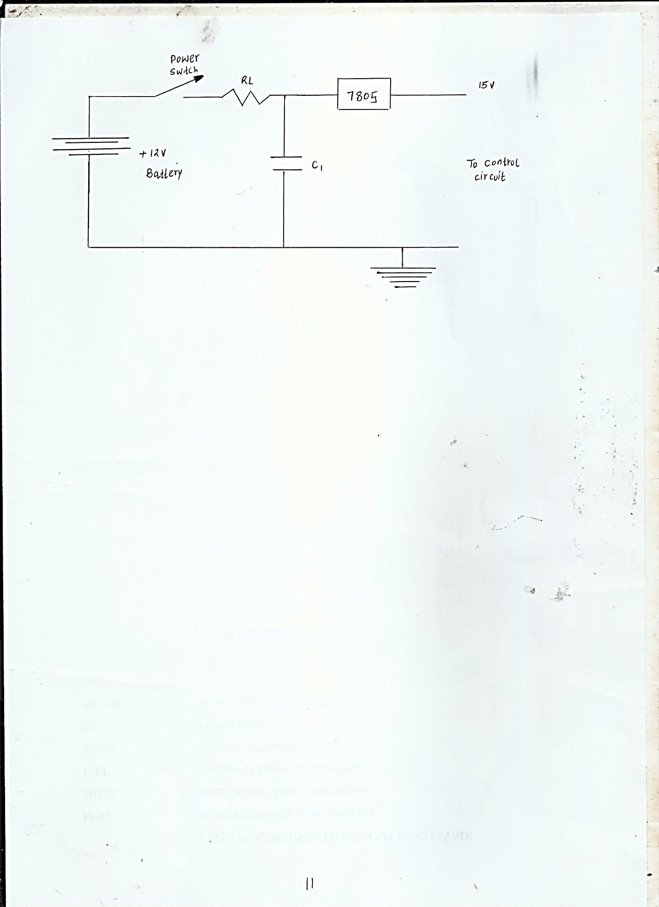

# 2.2.2 Design of the Infra-Red Transmitter

The circuit consists of two ass timer a stable multivibrator and Infra-red led driver serving as the transmitter. One stable multivibrator (IC2) function is to generate pulses with a frequency of 38khz. This choice of 38khz. The choice of 38khz is based on the infra-red receiver or module that operates on a 38khz carrier. The second multivibrator (IC) is used to generate a low frequency pulses to control the upward movement of the hydraulic jack. The modulated infra-red beam is directed towards the direction of the Infra-red receiver of the car jack mechanism.

# 2.2.3 Infra-red receiver

The Infra-red receiver circuit adopted for the circuit was borne out of the need for reliability. This was implemented using Infra-red receiver module especially designed for Infra-red reception of 38khz signals. It consists of the Infra-red receiver.

The Infra-red circuit used the Infra-red receiver module IPX-TSOPIZ38 model for the Infra-red detection circuit. The TSOP17XX- series are miniaturized receivers for the infrared remote control systems. PIN diode and preamplifier are assembled on load frame, the epoxy package is designed as IR filter. The demodulated output signal can directly be decoded by a microprocessor. TSOPI7XX is the standard IR remote control receiver series, supporting all major transmitter codes.

It has the following features;

* Photo detector and preamplifier in one package
* Internal filter for PCM frequency
* Improved shielding against electrical field disturbance
* IPIland and CMOS compatibility.
* Output active low
* Low power consumption
* High immunity against ambient light
* Continuous data transmission possible (up to 2400bps)
* Operating frequency is 38khz and supply voltage of 5v. The module was used for 38khz signal detection to control the hydraulic jack mechanism.

**Figure 4 Infra-red receivers**

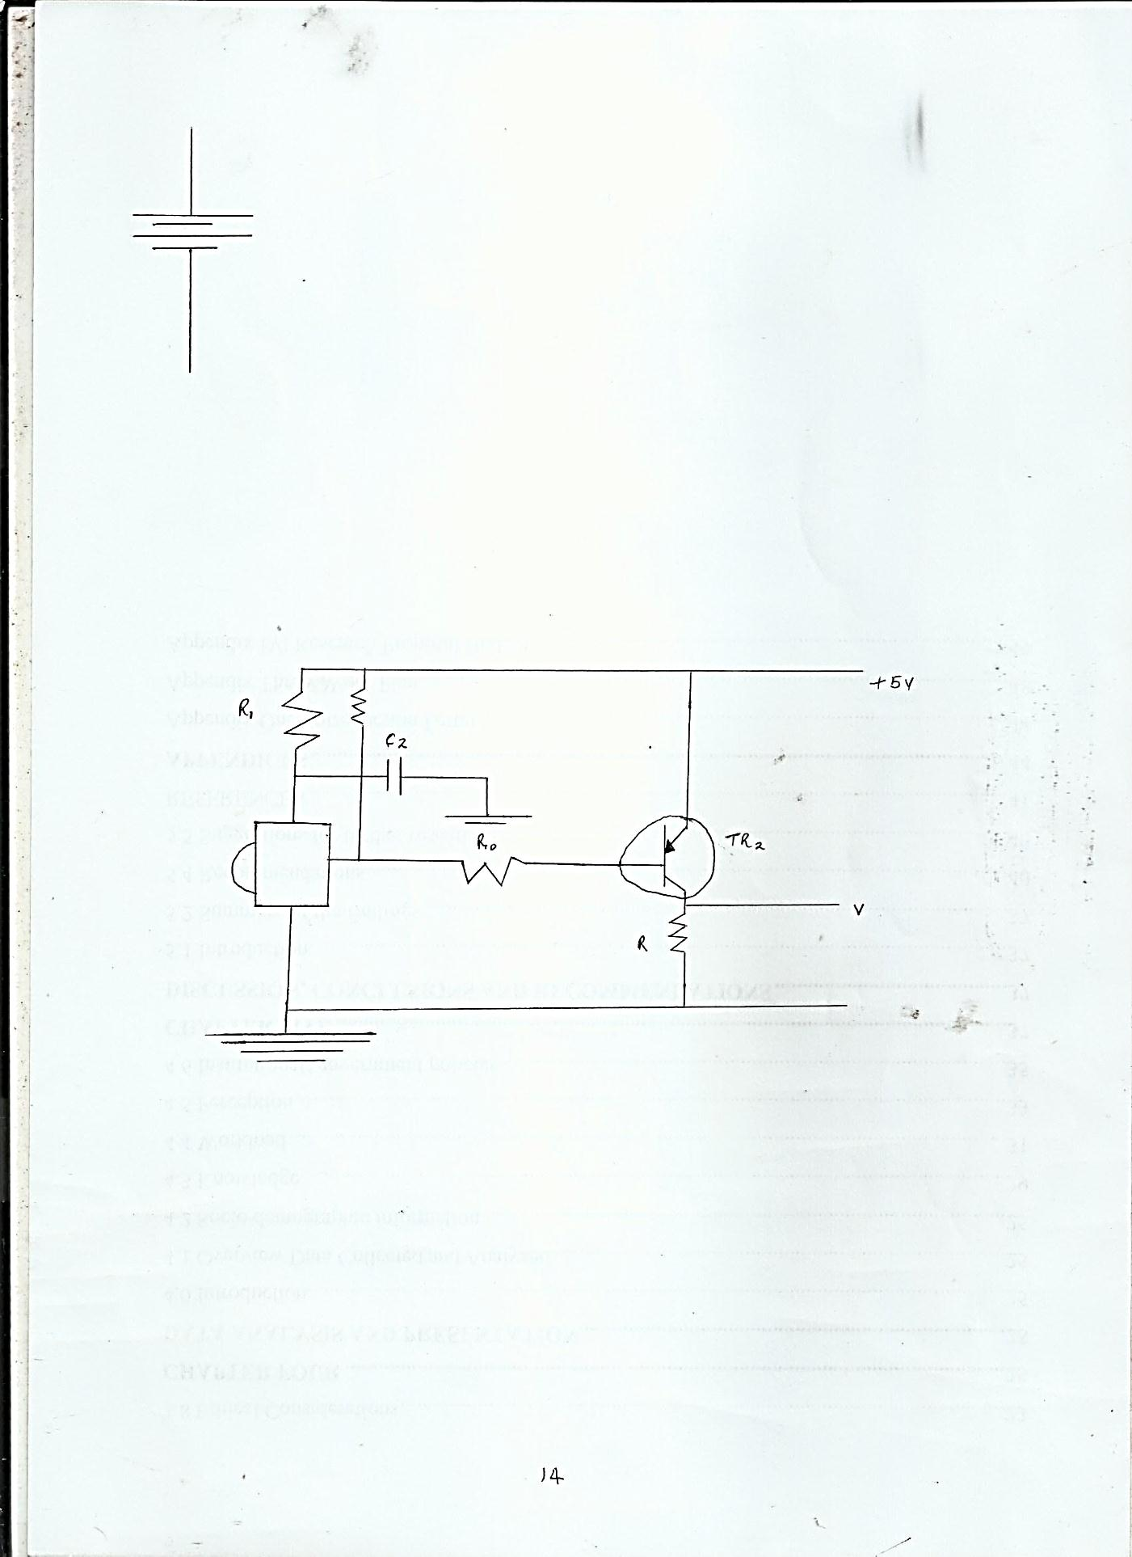

# 2.2.4 Micro-controller circuit

The micro-controller used in this work is microchip PICI16F84A.

It has only 35 single word instructions to learn and all instructions single-cycle except for program branches which are two-cycle. The features of the microcontroller as listed below.

* Operating speed. DC-20MHZ clock input
* 1024 words of program memory
* 68 bytes of data RAM,64 bytes of data EEPZROM
* 14 bit wide instruction words, 8 bit wide data bytes
* Direct, indirect and relative addressing modes
* Four interrupt sources

# 2.3 The cage material selection

This is made of flat bars made of high carbon steel due to the following properties;

1. Hardness
2. Less ductile
3. High compressive and tensile strength

**Specification and functions**

# 2.3.1The pumping unit

* The unit ports should be strong enough to withstand high fluid pressure.
* The design should prevent fluid flow back
* Minimum force should be applied at the handle to produce a large force.

# 2.3.2 The reservoir

* Should be strong enough to resist deformation during operation
* When fully filled a sixth of the inside space should be left without fluid to aid in fluid expansion.

# 2.3.3 House connections and fittings

* Should free from any leakage
* Should withstand high pressure that is built up

# 2.3.4 Check values

Should be free from any leakage

Should only open and close according to the set conditions

Should allow fluid flow in one direction.

# 2.4.5 The pumping and working cylinders

Should withstand high pressure build up

Should provide maximum resistance to wear of pistons.

**CHAPTER THREE**

# 3.0 Working principle of the inbuilt hydraulic jack

|  |  |
| --- | --- |
| **S/NO** | **PART NAME** |
| 01 | Wheel |
| 02 | Bearing |
| 03 | Hydraulic jack |
| 04 | Motor |
| 05 | Cam mechanism |
| 06 | Return spring |
| 07 | Hinge joint |
| 08 | Main frame |

When any button of the remote control is pressed, a signal is sent through the Infra-red hence the rotating of the motor operated by button pressed near any of the four wheels. Using the electric power of the motor, the can rotates. This is where rotary motion is converted to linear motion. The pumping rod is present at the center. Motor shaft is coupled with can. Battery is operated by a motor the motor is connected with cam.

It is rotated with the specified rpm the cam is connected to a hydraulic bottle jack when there is a continuous rotation of the cam, the circuit motion is converted to a reciprocating motions. That reciprocating motion is used to step up the bottle jack. The link is connected with the bottle jack is used to rise the arm. This arm connected to spring shaped is lowered down and it lifts the vehicle. Here we are converting the rotary motion into linear motion for lifting the vehicle using the jack which is fixed in the bottom of the axles by means of a frame. The motor is operated by control unit. It gets power from the battery. The four numbers of hydraulic jacks are arranged under the vehicle body. One shaped is connected to the cam and moving shaped. The link is used to provide the smooth operation during the up and down movement. When we press the button on the remote the motor rotates. When the cam rotates, the supporting shaped moves up which makes the return spring shaped to move down by touching the ground and lifts any of the wheels up according to the button pressed on the remote. The wheels are grounded safely even after the wheel puncture on any fault in the vehicle. The mechanism will be operated by automatically when the pressure sensor is fitted in the tyre.

# 3.1 Design calculation for hydraulic jack

The weight in the lifted is 1000kg or 1000 N

Let us find the effort required by the human.

Formula

F=PXA

1000=PX 11/4 x (50 x 10-3)2

P=1000x 4/11 (50 x 10-3)2

P=509.29 x 10-3 N/M2

Force required at the working piston

F=PXA

= 509.29 x 103 x 11/4 (15x10-3)2

F= 90N=9KG

Therefore the force to be applied at the working piston is 90N/, which is 10 times lesser than the weight to be lifted.

Hydraulic bottle jack

Cam arrangement

Arm

**Hydraulic bottle jack**

The hydraulic bottle jack saddle extension raw cylinder handle sleeve handle assembly carry handle and release valve. Pressure is applied to the handle assembly it is possible to get a lift or ram per stroke of the handle assembly. The release valve is used to release the pressure inside the cylinder bottle jack are placed in a horizontal position.

Bottle jacks are versatile because the horizontal position makes it possible to place them in tight spots and provide good leverage. The bottle jacks have proven useful in search and rescue missions following earthquake damage. As a result bottle jacks are standard equipment in fire houses for search and rescue teams. They are also used for elevating, thrusting, weighing or forcing requirements. The base of bottle jacks is welded for strength. All models of bottle jacks are capable of working in erect, angled or horizontal positions.

# 3.2.1 Steps to use and operate

1. Before operating the jack you must purge its hydraulic circuit in order to eliminate any possible air in the system.

2. To purge the system open the release valve, turning it anticlockwise. Then with the air of the lever operate the pump several times.

3. Close the release valve with the lever in a clockwise direction until it is fully closed.

4. The jack is set up for use.

5. To lower the jack turn the release valve vey tardily in a counter clockwise direction.

6. Always keep the jack in erect position, with the ram, extension screw and pump retracted after use.

7. If you require operating the jack, in a horizontal manner the pump should be located on the lower side of the jack.

# 3.3 Return spring

Springs are placed between the supporting shafts and return spring shaft. It is used to reduce the return time of return spring shaft. When the total extension of the hydraulic cylinder the spring fully compressed. When the wheel comes across a relegate on the road, it ascends and distracts the spring, thereby, towing energy therein. On discharging, due to the elasticity of the spring material, it bounces thereby expanding the stored energy. In this way the spring starts oscillate, with amplitude decreasing gradually on internal friction of the spring material and function of the suspension joints till oscillates die down.

# 3.4 Cam

A cam is projecting part of a rotating wheel a shift that strikes a lever at one or more points on its circular path. The cam or crank is used to deliver impulse of an eccentric disc that produces a smooth reciprocating (back and forth) motion in the follower which is a lever making contact is with the hydraulic jack. This cam or crank is connected with a slider mechanism that converts reciprocating motion to rotary motion.

# 3.5 Motor

A machine that convers direct current power into mechanical power is known as dc motor. Its generation is based on the principle that when a current carrying conductor is placed in a magnetic field, the conductor receives a mechanical force.

# CHAPTER FOUR

**Choice of materials**

# 4.1 Properties

The material selected must have the essential properties for the proposed application. The various requirements to be quenched can be weight, surface finish, inflexibility, ability to withstand environment aggress from chemicals, service life, valuableness etc. The following types of principle properties of materials resolutely affect their selection.

* Physical
* Mechanical
* From manufacturing point of view
* Chemical

# 4.1.1 Physical properties

* Melting point
* Thermal conductivity
* Specific heat
* Co-efficient of thermal expansion
* Specific gravity
* Electrical conductivity
* Magnetic purposes etc

# 4.1.2 Mechanical properties

* Strength in tousile
* Compressive sheer
* Bending
* Torsion
* Buckling load
* Fatigue resistance
* Impact resistance
* Elastic limit
* Endurance limit
* Modules of elasticity
* Handiness
* Wear resistance
* Sliding properties

# 4.1.3 Manufacturing point of view

* Cast ability
* Weld ability
* Surface properties
* Shrinkage
* Deep drawing etc.

# 4.2 manufacturing case

Requirements of lowest possible manufacturing cost or surface qualities obtainable by the application of suitable coating substances may demand the use of special materials.

# 4.3 Quality required

This generally affects the manufacturing process in the end of material. For example, it would never be desirable to go casting of a less number of components which can be fabricated much more economically by welding or hand forging steel.

# 4.4 Availability of material

Some material may be scarce supply. If then becomes obligatory for the designer to use some other material which though may not be a perfect replacement for the material designed.

# 4.5 Space consideration

High strength materials have to be identified because the forces involved are high and space are restricted.

# 4.6 Cost

In selection of material the cost of material plays an importance part and should be considered. factors like scrap utilization, appearance, and non –maintenance of the designed part are involved in the selection of proper materials.

# CHAPTER FIVE

# 5.0 Results and conclusion

# 5.1 Parameter measured

|  |  |
| --- | --- |
| Lift capacity (tons) | 2 |
| Min. Lift weight (in) | 7 |
| Max. Lift weight (in) | 11 ½ |
| Ram Travel (in | 4 ½ |
| Screw Top Adjustment (in) | 1 ¾ |
| Operator | Manual |
| Handle included | yes |
| Dimensions LxWXH (in) | 3 ½ x 3 5/8 x 7 |

**Battery: Voltage-12V**

# 5.2 Conclusion

An inbuilt hydraulic jack system can be easily attached to all currently manufactured automobile chassis. There is a front suspension hydraulic jack that is mounted externally to the rear suspension of the automobile between its wheels. The system operates on the hydraulic power. This arrangement has many advantages such as maintenance and servicing of vehicle. It reduces the security tension and easy to implement quick lifting is possible and suitable for heavy load for about 100kg or 1000N. The force to be applied at the working piston is 10 times than the weight to be lifted with the help of this system the driving of vehicles will be easy. Arrangement is also very useful for heavy loading vehicles and a single person can go on long drive.

# 5.3 Recommendation

The following recommendations have been made based on the knowledge one has acquired from the design and construction of this project and personnel observations in the course of the project work.

Use of efficient codes for better and faster response time.

To make the project applicable for heavy duty vehicles.

To use of more efficient mechanism for the jack counted and lifting of heavy loads.

To increase lifting travel verge from as low as is on to high as 40cm.

# References

1. Mohammed Abuzaid, Prof Surendua Agarwal.
2. Applied Mechanics and strength of materials Dr. R.K Bausal.
3. Technical Electronics II. ELBS \, 1978. Meadows R.G
4. Mastering electronics Mc Grew Hill New York, 1988, 3rd Edition chapter 9,10.
5. Whom Jackallan blogsport.com
6. <http://www.swanthore.com/9292B/remote> control Jack Ez-lug.Combo/p aspx.
7. Electronics II, ELBS, 1998-Green D.C.
8. Electrical technology, ELBS with longman, seventh edition, 1995, pp 378-382, 392-400, 523-532.
9. A test book of automobile engineering by Dr. Kirspal Singh
10. In built hydraulic jack in automobile vehicles, international journal of innovations in engineering and technology, p.76-85 Vol 2 issue 2 April 2013- Mohammed Abzaid
11. Light Talk on Heavy Jacks, old House Journal:37-William (ox July, 2001).